Note: The donor voluntarily provided the following information. This information will be disclosed to future parents as an aid in their selection process.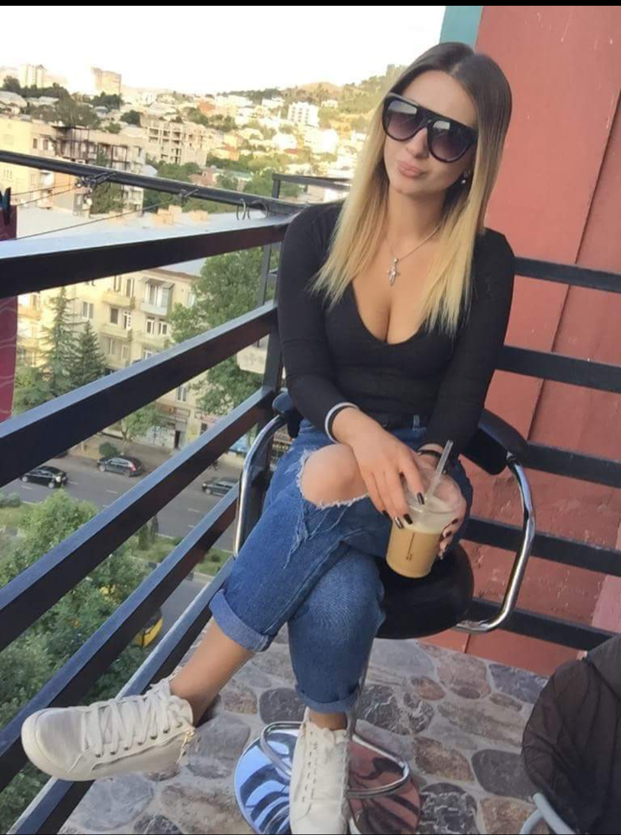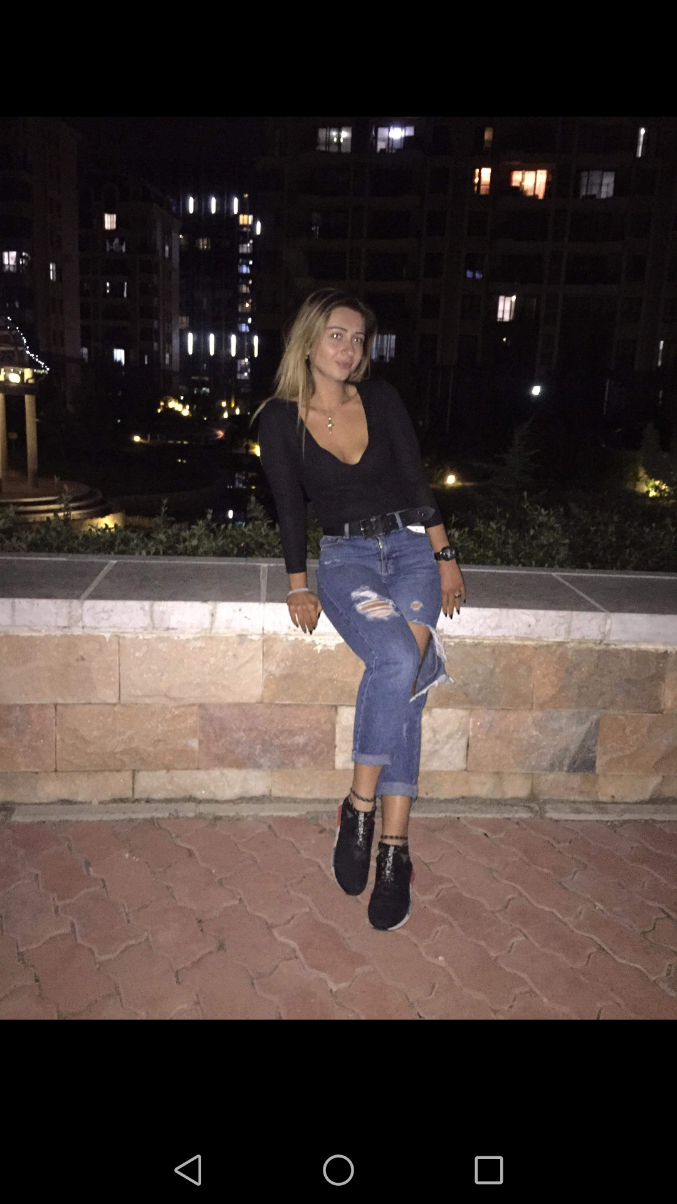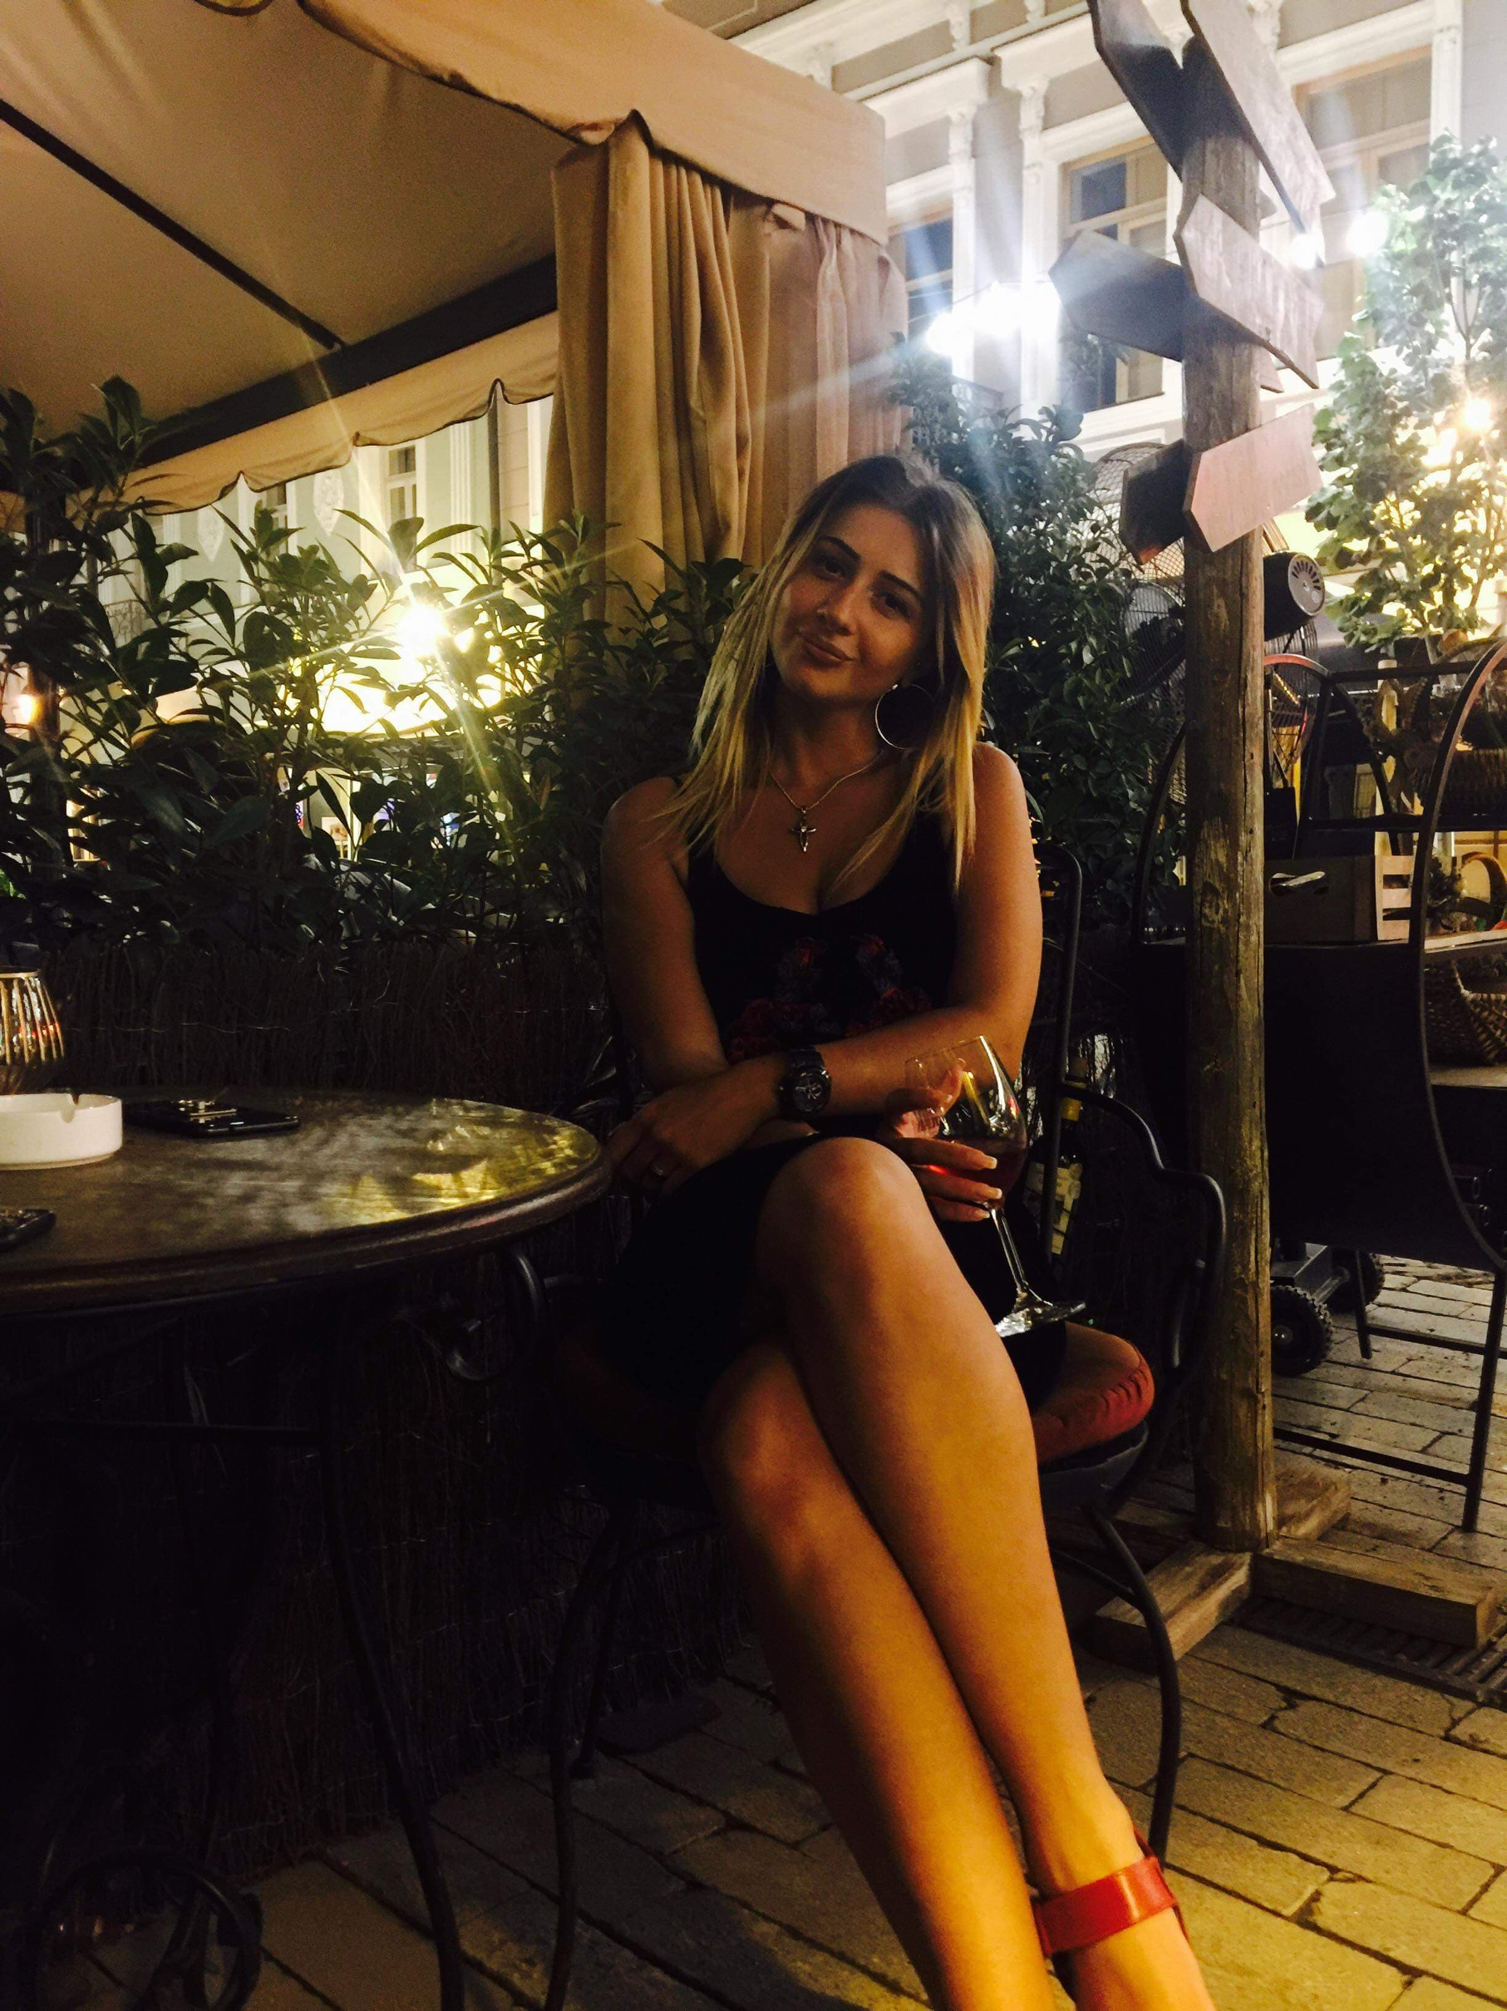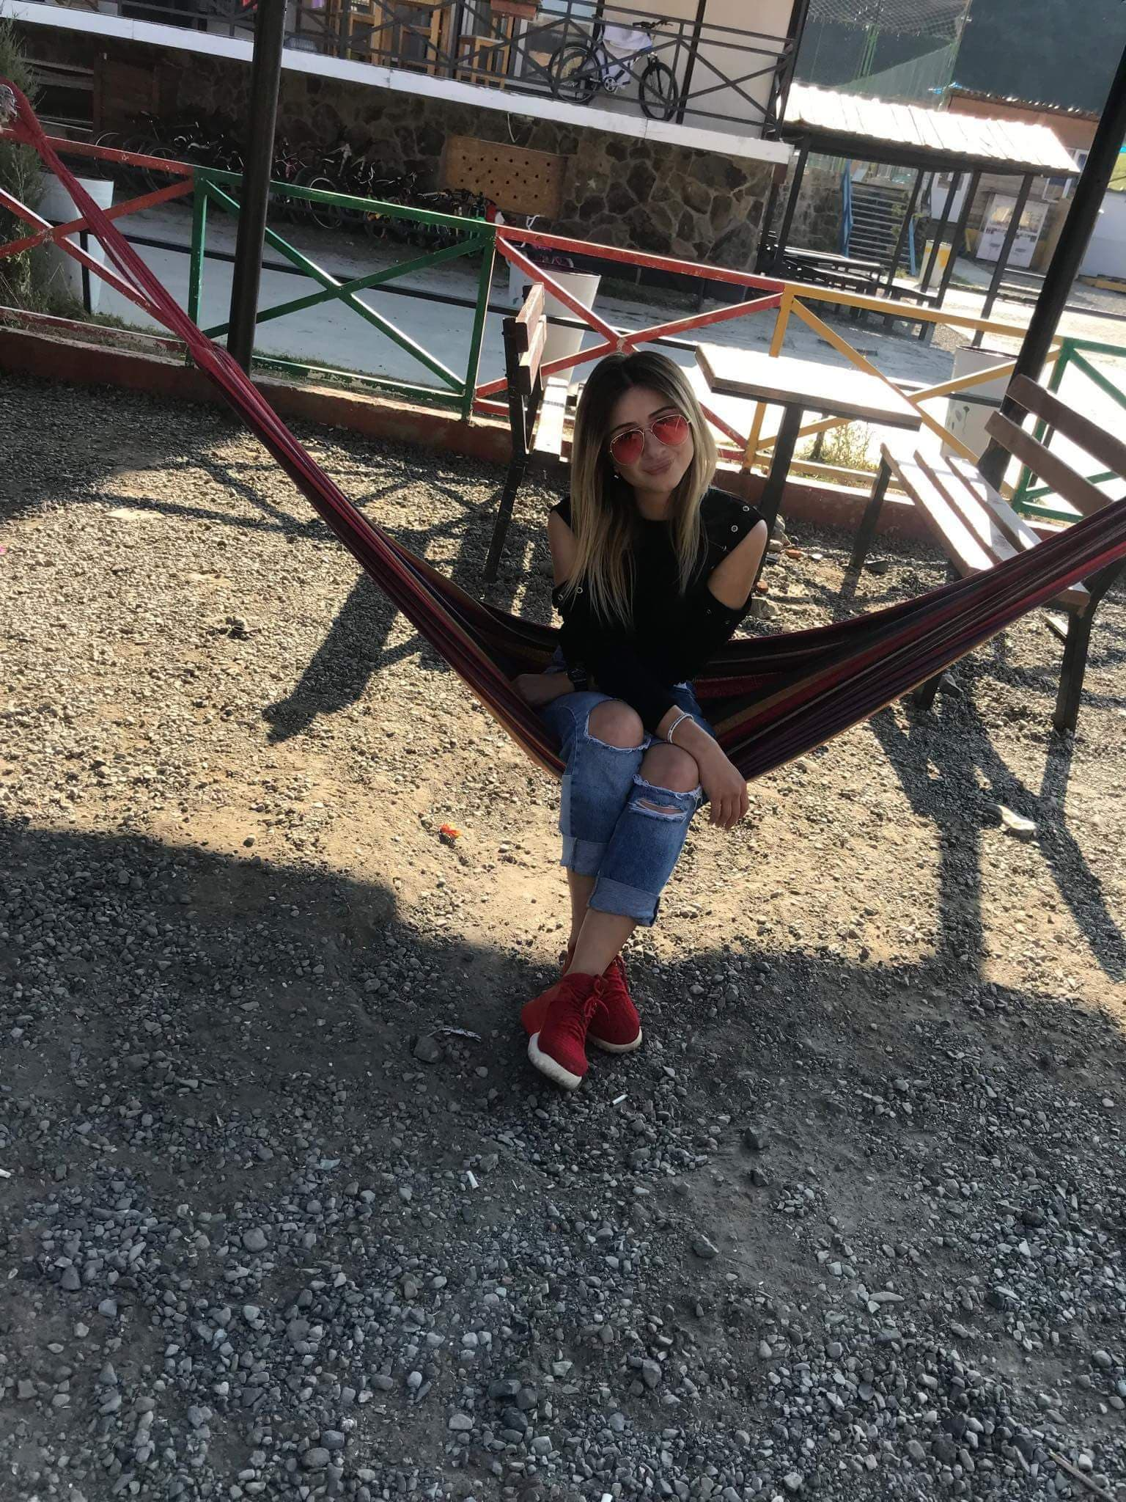

CODE | EDABC502
OCCUPATION | Housewife
HEIGHT | 1.69 m
AGE | 1997
COMPLEXION | Fair
BUILD | Slim
COLOUR OF EYES | BROWN
COLOUR OF HAIR | BROWN
EDUCATION | UNIVERSITY STUDENT
Blood Group | O+
Weight | 51kg

Family Characteristics
RELATIVE | ALIVE: YES/NO | PRESENT AGE OR  AGE AT DEATH | PRESENT MEDICAL  CONDITION OR  CAUSE OF DEATH
Mother | Yes | 36 | healthy
Maternal Grandmother | Yes | 56 | healthy
Maternal Grandfather | Yes | 58 | healthy
Father | Yes | 43 | healthy
Paternal Grandmother | Yes | 67 | healthy
Paternal Grandfather | Yes | 68 | healthy
Sister | Yes | 11 | healthy

Medical History
QUESTION | ANSWER
1. Do you have any medical illnesses (i.e. asthma, diabetes, seizure disorders, tuberculosis, etc.)? | NO
2. List all Surgeries: | NO
3. Do you have any allergies (food, pollen, bee stings, etc.)? Please list: | NO
4. Do you have any allergies to medications? Please list: | NO
5. Describe any childhood allergies you may have out grown? | NO
6. List medications including prescription, over the counter, vitamins or herbs you Are currently taking? | NO
7. Are there medications you have taken in the past five years. If so, please list: | NO
8. Have you ever sought psychological counseling? | NO
9. Have you, or currently taking medication for a psychological condition? | NO
If yes, what medications have you, or are you currently taking? | NO

